4. Use git log to look at the file structure and commits.  Note how, many commits, trees, and blobs there are.  **Take a screenshot.**

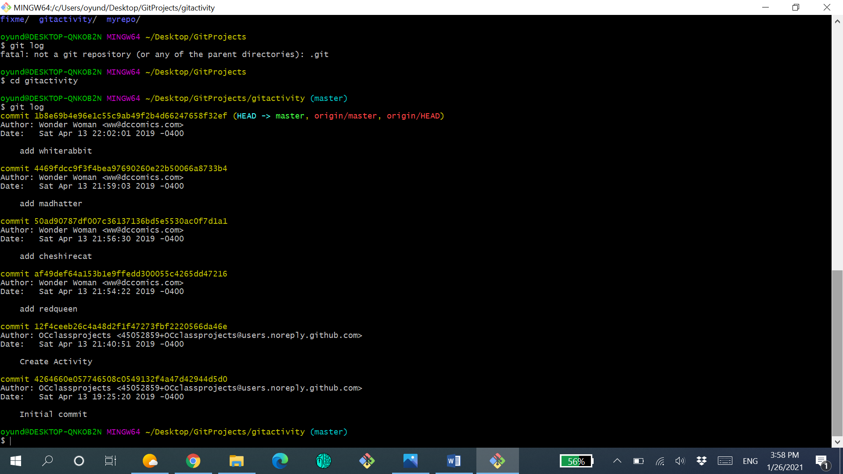

Blobs- **0**

Trees-**0**

Commit-6

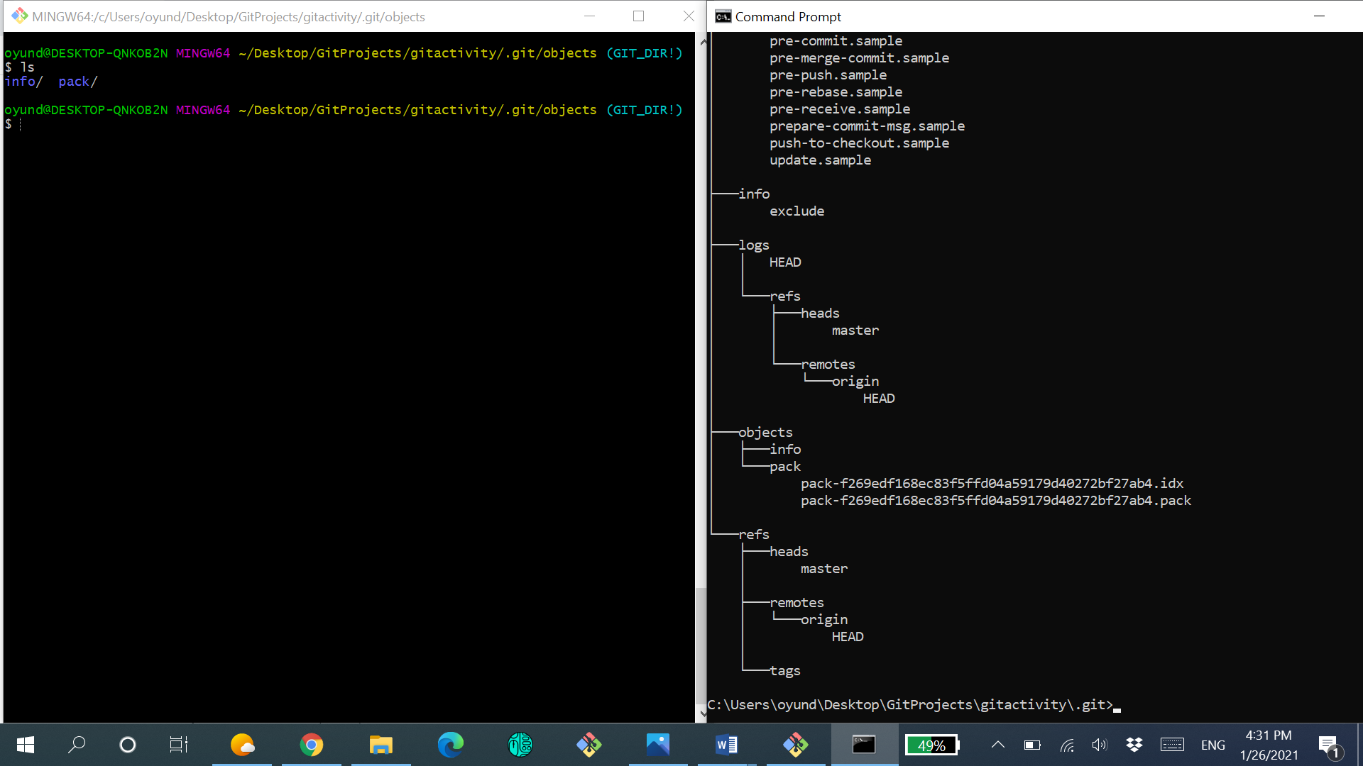

9. Add and commit your new file to your branch. **Take a screenshot.**

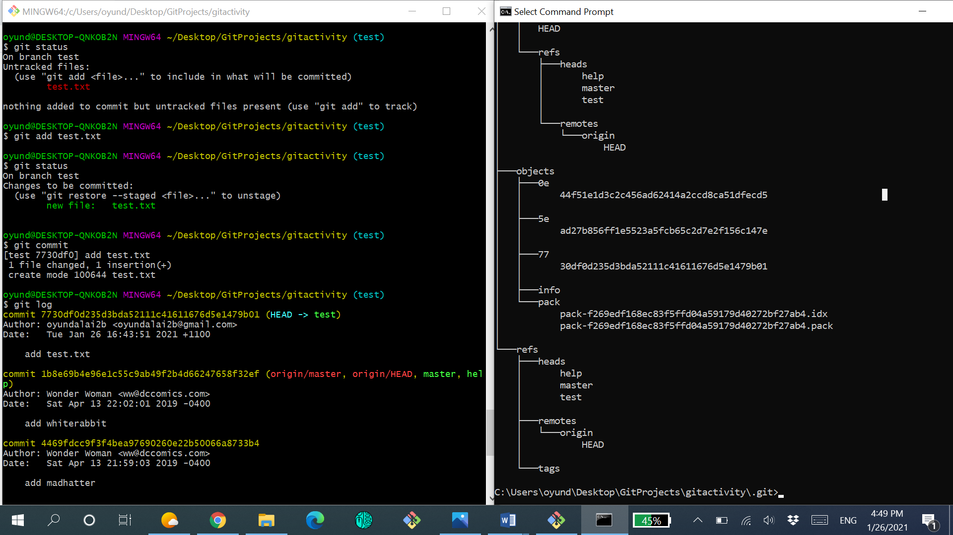

10. Run a  git fetch  to see if any new files are on the main repo. **Take a screenshot.**

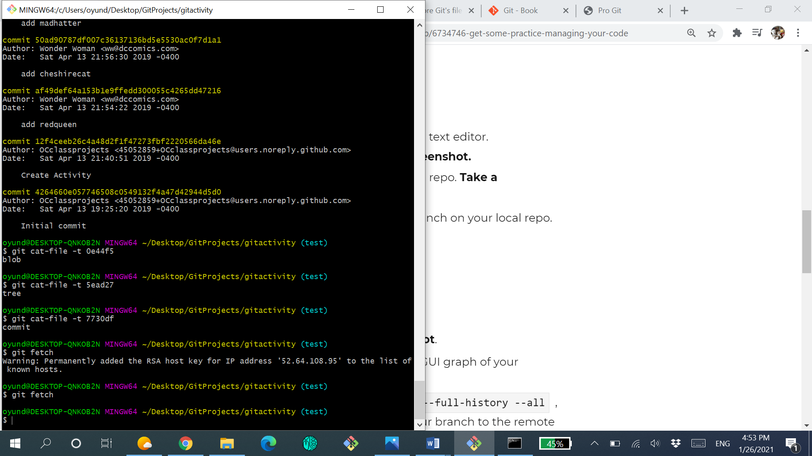

13. Move the 2nd commit to a spot after the 4th commit

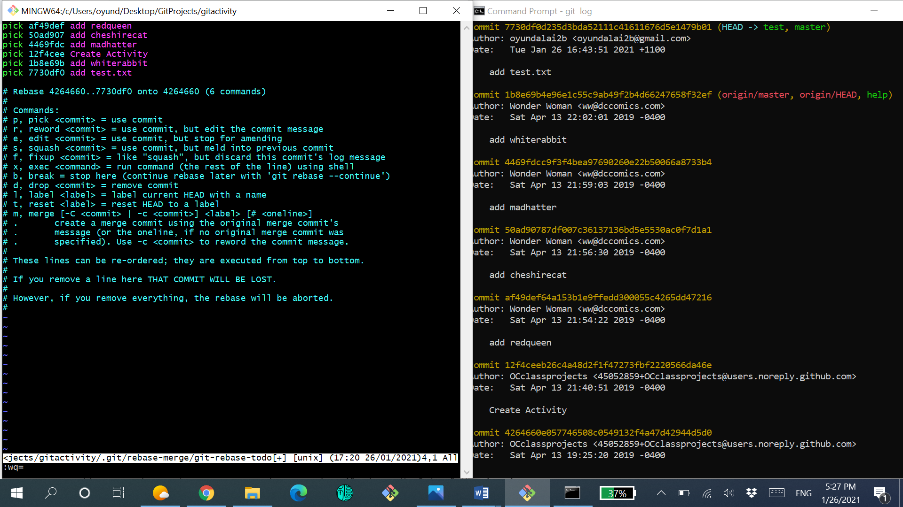

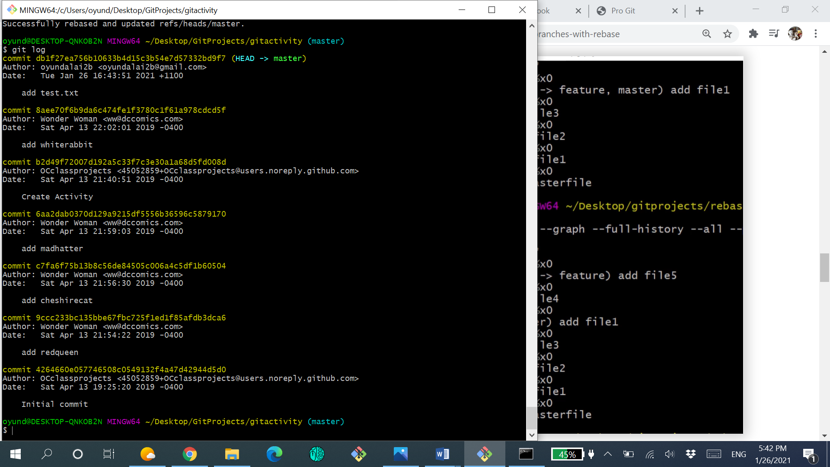

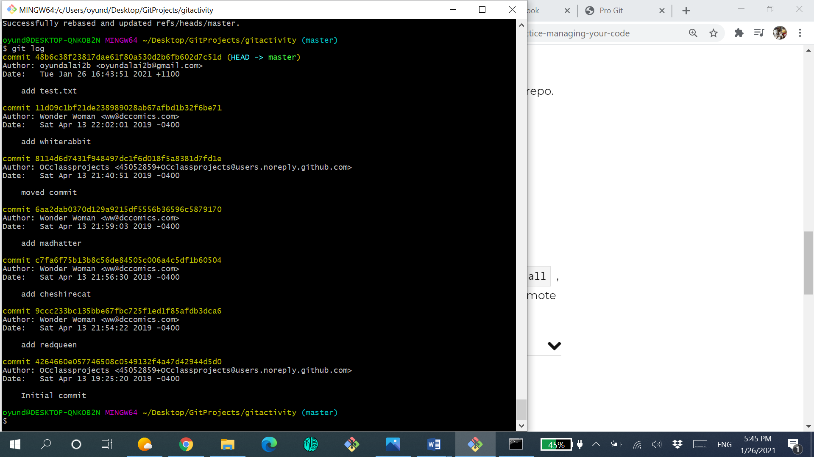

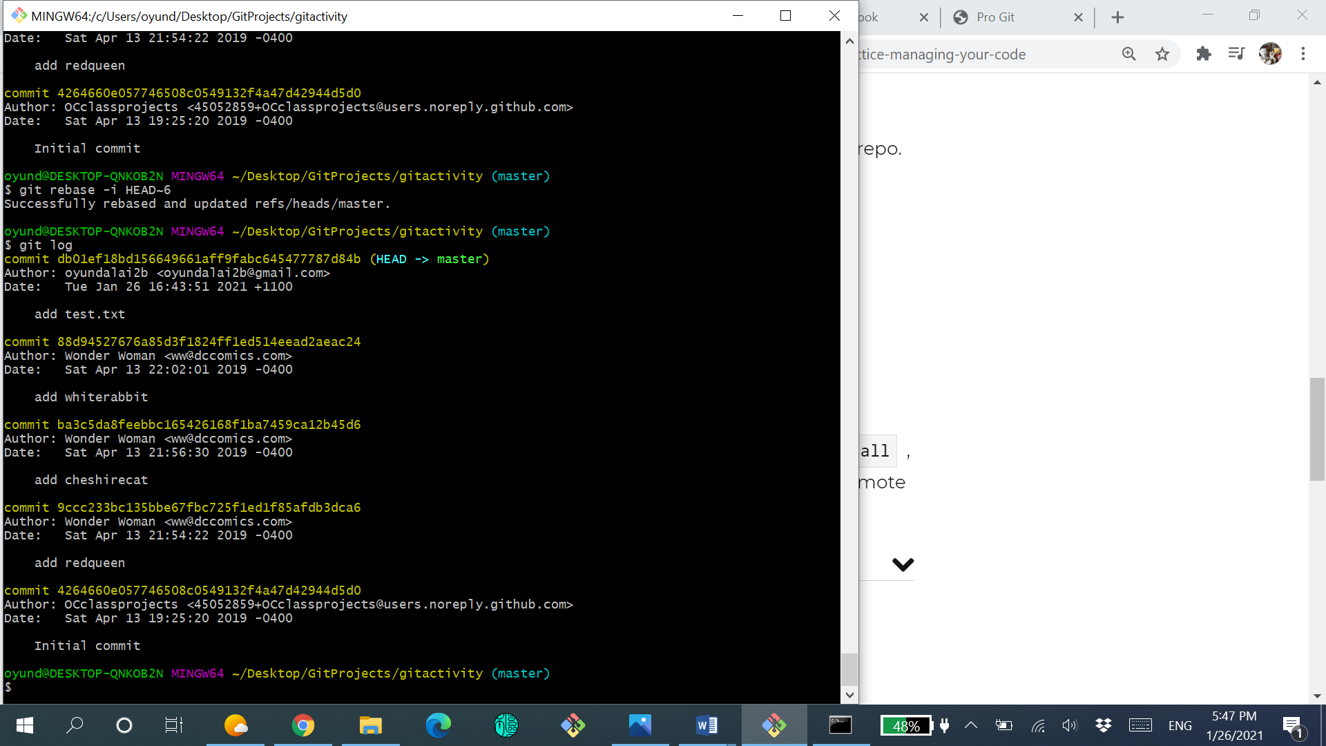

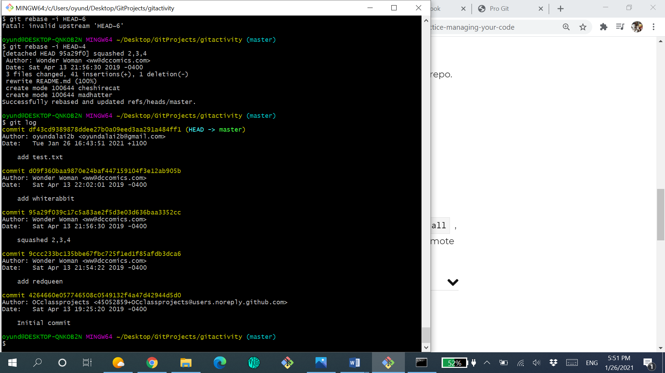

17. Use  git reflog  to look at your work.  **Take a screenshot**.

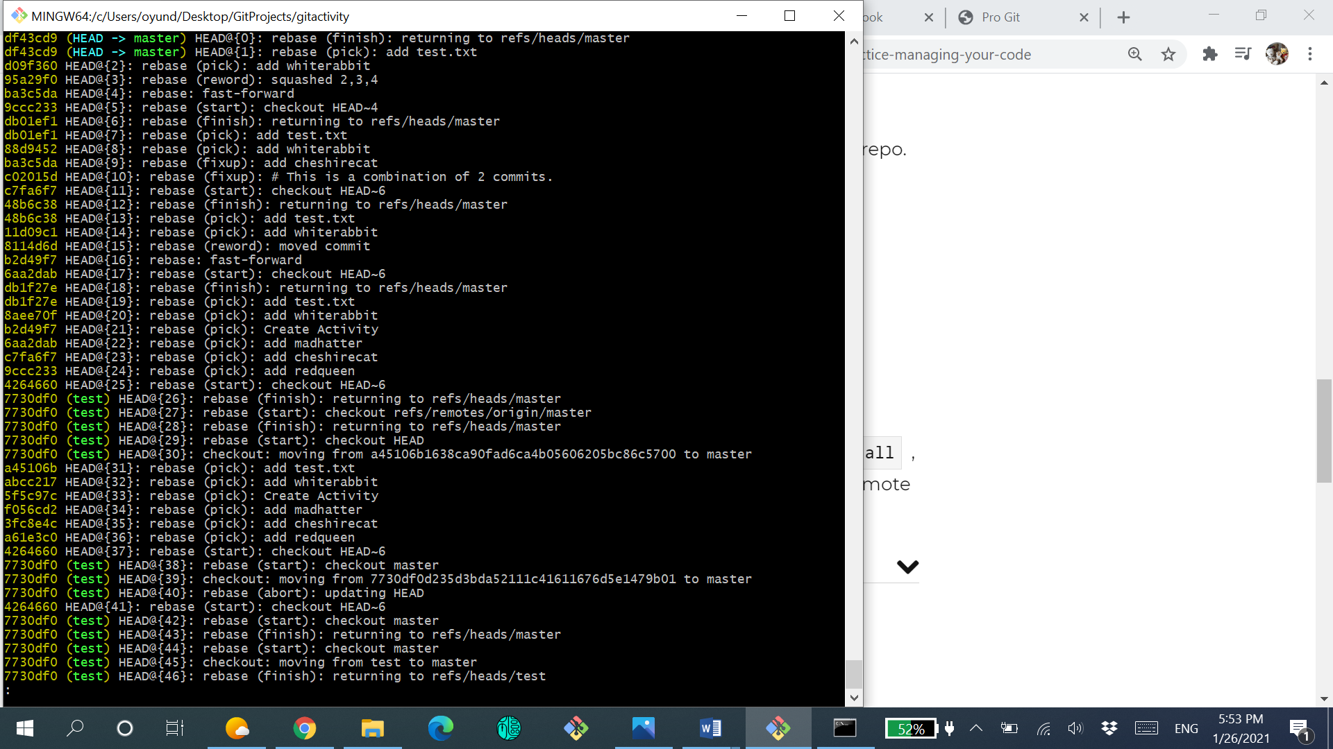

18. Bonus (advanced): type in  gitk --all, screenshot the GUI graph of your repository, and commit it to your branch.

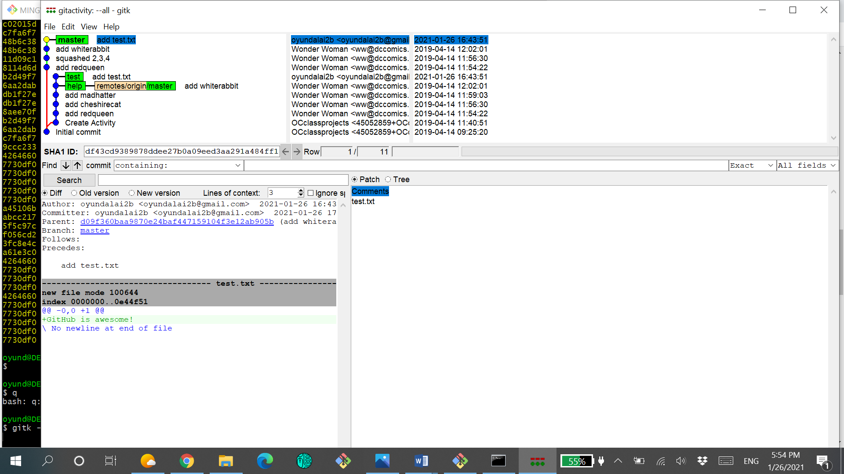

19. Bonus (advanced): use the command  git log --graph --full-history --all , take a screenshot, and commit it to your branch. Push your branch to the remote repository and create a pull request. **Take a screenshot.**

